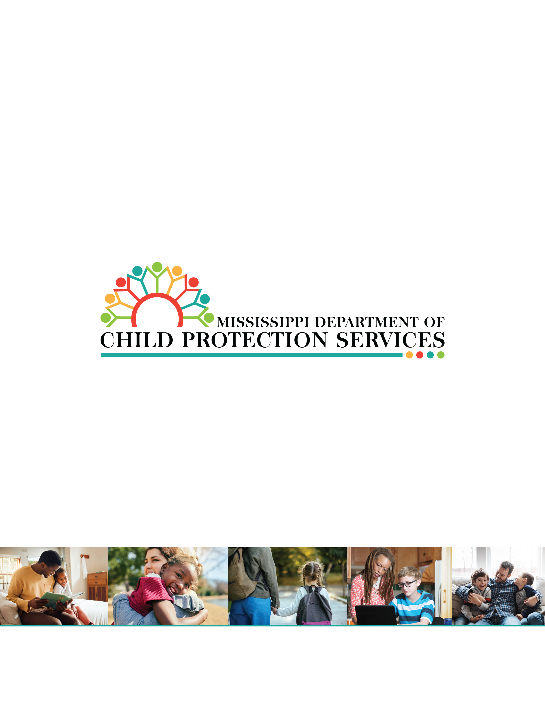

Mississippi opted into the “A Home for Every Child” initiative on March 10, 2026. To advance strategies that increase the number of both relative homes and licensed foster homes available for placement of children, while safely reducing the overall number of children in foster care, the Mississippi Department of Child Protection Services (MDCPS) established the following priorities:
- Children in custody will have access to licensed/vetted home-based settings
- Children in custody are placed in homes that support stability, connection and safety
- Children remain safe at home whenever possible
To support these priorities, MDCPS established a multidisciplinary workgroup comprised of representatives from each division of the agency. Agency leadership also partnered with the Mississippi Legislature, the Department of Human Services, the Administrative Office of Courts, youth court officials, community stakeholders, and foster parents.
The overarching goal of this Program Improvement Plan (PIP) is to reduce the gap between the number of foster/relative homes available to take placement of children and the number of children in foster care while increasing the prevention services that provide critical needs to the community. The strategies outlined below represent Mississippi’s focus over the next twenty-four (24) months as the agency works toward achieving this goal.
Mississippi offers prevention services as an intervention to help families address identified safety threats and to manage risk factors with the goal of children remaining within their families and communities when safe to do so. Home based and community services are used to manage and monitor safety threats and mitigate the likelihood of future child welfare involvement.
Prevention services and safety planning focuses on strengthening families, addressing crisis management, increasing child and family well-being, and developing sustainable safety networks and support aimed at lowering the risk of future child abuse or neglect.
Through participation in the PIP pilot, Mississippi will prioritize locating and evaluating relative homes as placement options to increase the number of family homes available for placement of foster children. This strategy reflects a comprehensive approach to elevate the importance of relative involvement when children enter foster care. By strengthening efforts to locate and evaluate relatives, MDCPS intends to see an increase in the number of children placed with family members, improve placement stability, and increase timely permanency.
As with the relative homes, MDCPS is emphasizing the recruitment and retention of traditional foster homes. The agency has reduced the time it takes to license a home, focused recruitment efforts in high need areas, and created a communication campaign to educate communities about the need for foster families.
“Room for One More” is MDCPS’s foster parent recruitment and engagement campaign designed to support efforts to increase awareness and recruit additional foster families. The ultimate goal is to establish a 1:1 ratio of available homes for every child in foster care who needs placement. MDCPS intends to build on these efforts through the implementation of the PIP.
Mississippi’s PIP focuses on three priorities with emphasis on safety, permanency, and well-being of children and families through enhanced prevention efforts, increased licensing of relative and traditional foster. These priorities support the agency’s broader strategic goal of A Home for Every Child through the Room for One More campaign.

Priority | Strategies | Monitoring
- Children in custody will have access to licensed/vetted home-based settings | Strengthening retention of foster and kinship caregivers through targeted recruitment and structured peer support. | - Net gain  - Percentage of placements reaching 90 days with no safety concerns or corrective action plans  - Increase the percentage of children attaining timely reunification, guardianship, or adoption
 | Strengthening stability by utilizing place matching for improving placement success and decreasing placement disruptions.
 | Conduct ongoing diligent searches of relatives/kin throughout the duration of the case ensuring ongoing engagement with family and community support.
- Children in custody are placed in homes that support stability, connection and safety | Increase early identification, notification, and engagement of relatives and kin within the first 30 days of entry into foster care | - Increase the number of newly licensed relative homes  - Increase the percentage of children whose initial placement is with relatives
 | Increase the number of licensed and unlicensed relative homes available for the placement of foster children through enhanced diligent search efforts
 | Conduct ongoing diligent searches of relatives/kin throughout the duration of the case ensuring ongoing engagement with family and community support
- Children remain safe at home whenever possible | Track the availability and utilization of Prevention Services. | - Number of families referred to Intercept (the currently available Evidence Based Program)  - Number of families that successfully completed Intercept services  - Number of families referred to Community Based Services
- Children remain safe at home whenever possible | Increase the number of families referred to Evidence Based and Community Based Services to prevent entry into foster care.
- Children remain safe at home whenever possible | Utilizing intake data for counties with high call volume to coordinate expansion of prevention efforts and services.

